Omicron

Harshit Kumar Gupta
Ajay Prem Shankar
Surya Pratap
Abhishek Shukla
KNIT Sultanpur



Online Market

Software Requirement Specification
On

“ Online Market”

Submitted By: Harshit Kumar Gupta
Ajay Prem Shankar
Abhishek Shukla
Surya Pratap Gaur
Guided By :Mr Abhay Kumar Agrawal
Team Name : Omicron
Collage Name : KNIT Sultanpur

ACKNOWLEDGEMENT

The satisfaction that accompanies that the successful
completion of any task would be incomplete without the
mention of people whose ceaseless cooperation made it
possible, whose constant guidance and encouragement
crown all efforts with success.
We are grateful to our project guide Mr. Abhay Kumar Agrawal
for the guidance, inspiration and constructive suggestions
that helpful us in the preparation of this project.
We also thank our colleagues who have helped in successful
completion of the project.
Harshit Kumar Gupta
Ajay Pram Shankar
Abhiskek Shukla
Surya Pratap Gaur
Table of Contents

- Introduction---------------------------------------------------------------------------
1.1Rational Modified Model-------------------------------------------------------------------04

- Methodology-------------------------------------------------------------------------

2.1 Purpose ----------------------------------------------------------------------------------05
2.2 Scope ------------------------------------------------------------------------------------06
2.3 Definitions, Acronyms and Abbreviations------------------------------------------07
2.4 References ------------------------------------------------------------------------------08
2.5 Technologies/Tools to be used-------------------------------------------------------09

2.6 Functional Components-------------------------------------------------------------11

2.6 Design Constraints-------------------------------------------------------------------12
2.7 Overview and User Characteristics-------------------------------------------------12

- Overall Description --------------------------------------------------------------

  - Product Perspective----------------------------------------------------------------13

  - Hardware and Software Requirement------------------------------------------14

  - System Users---------------------------------------------------------------------15

  - Architectural Diagrams ----------------------------------------------------------16

  - Deployment Diagrams----------------------------------------------------------21

  - Assumption and Dependencies-------------------------------------------------21

4. Specific Requirements ---------------------------------------------------------- ---

4.1 Use-Case Diagrams ---------------------------------------------------------------- 22

4.2 Activity Diagram----------------------------------------------------------------------25

4.3 Sequence Diagrams------------------------------------------------------------------33

5. Key Features -----------------------------------------------------------------------------

5.1 Supplementary Requirements-------------------------------------------------------42

5.2 Use of XML ----------------------------------------------------------------------------43

5.3 Plus Points in Design ------------------------------------------------------------------44

1.Introduction:-

  - Relational Unified Process

The Rational Unified Process brings together elements from all of generic process models, supports iteration and illustrates good practice in specification and design.
The RUP is normally described from three perspectives:

Dynamic Perspective- It shows the phases of model over time.

Static Perspective – It shows the process activities that are enacted.

Practice Perspective –It suggests good process activities to be used during process.

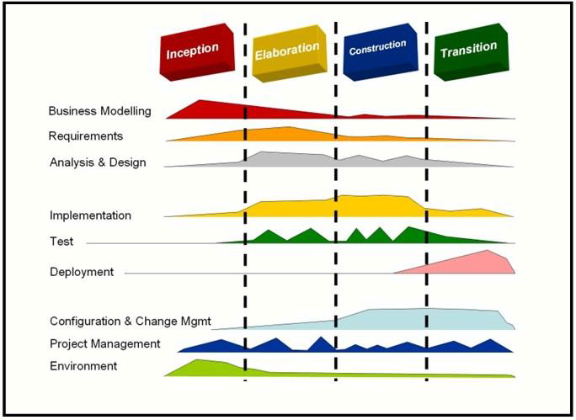
Phases of RUP

The different Phases in RUP are-

Inception

The goal of the inception phase is to establish a business case for the system. Identifying all external entities that will interact with system and defining these interactions. This information
is used to assess the contribution of system to business.

Elaboration

The goals of the elaboration phases are to develop an understanding of problem domain, establishing an architectural framework, develop project plan and identify key project risks.

Construction

This phase is concerned with system design , programming and testing .Parts of the system
are developed in parallel and integrated during this phase.

Transition

This final phase of RUP and is concerned with moving system from development community to the user community and making it work in real environment.

2.1 Purpose :
Online marketing System is web application which provides online marketing to everyone at their desktop.IT enabled academic world aims at the computerization of market, to divert the attention from the trivial details of a marketing system to better aspects of product specification,

Main Objective of this project is to build an E- Market where people can buy, sell or advertise products. Here, suppose one person wants to sell his car then he can go to this e market and advertise his product for sell. He need to fill some basic information about his product(car in this case). Now suppose some other customer wants to buy some used car then he can search for it from the site by providing some basic information.

There are features like email notifications/reminders, report generators etc in this system. A better study Authorities can have a graphical analysis of the working system too.

2.2 Scope :

- Secure online registration and authentication of all users.
- Profile management facilities with customizable skins.
- Graphical analysis for the authorities to efficiently manage the resources.
- Hierarchical structure for different users, to ease administration.
- Central repository in the form of a database, which is only accessible by the Data Manager.
- FAQ section for helping the users.
- A separate module named RFC (Request for A Change) is provided to bridge the communication gap between authorities and end users. It provides provision for every user to make any changes in the administration via posting suggestions on it.
- Guests have an option of visiting metadata and history reservation of any book to know more about that.
- A Person should be able to login to the system through the first page of the application and change the password after login into the system.
- Basic information for user who just visit the site.
- Enrollment is must for users who wish to see details of any products or want to buy/sell any product. For enrollment he needs to provide some basic information like Name, Contact no/email id, userid and if user wants to sell something then he needs to fill description part of the product.
- Registration page should be available for registering in the site. Temporary password should automatically send to users contact no/ email id and after first login user should be able to change it as per his convenience.
- User who registered in the site must be able to get search box where he can search for products which he wants to buy.
- User can also advertise like: house for rent, temporary uses of playing kits etc.
- After registration, there should be an auto mail forwarded to user in his contact no/e-mail id.
- User should also be able to de-register from the site by providing user id and password with some security question.
- auto reply facility to customers who found that some other customer has shown interest in his product.
- Employees should be able to maintains all types of request, information etc which is required for giving 24/7 services to online users.
- Admin authority should be given to director.

  - Definitions, Acronyms and Abbreviations :

- JSP : Java Server Pages
A leading server side technology for creating dynamic web content.

- JVM : Java Virtual Machine
needed for running java programs.

- HTML - Hypertext Markup Language
It is used for creation of static web pages.

- J2EE - Java 2 Enterprise Edition –
A programming platform for development of multitier java applications and running distributed java.

- XML - Extensible Markup Language.
It is a text based format that let developers describe, diliver and exchange structured data between a range of application to clients for display and multiplication.
XML provides a very rich system to define complex documents and data structures.

- DB2 - DB2 Database Server
A database management system that provides a flexible and efficient database program platform to maintain records .

- WASCE – WebSphere Application Server Community Edition
                - It is an Application Server that runs and supports J2EE and web service application.

- HTTP - Hypertext Transfer Protocol
Transaction oriented client- server protocol

- SSL- Secure Socket Layer

- HTTPS - Secure Hypertext Transfer Protocol –
It uses Secure Socket Layer for secure transmission of data.

- RAD – Rational Application Developer
It is a developer tool that helps to design web pages and also helps to design the diagrams like ER ,Database Schema diagrams and to generate DDL.

- AJAX – Asynchronous Java Script and Extensible Markup Language.
It is widely used for sending request and retrieving response without reloading web pages.
It's a method to utilize the abilities of JavaScript, the Document Object Model, and XML to create interactivity on the web.

- RSS – Really Simple Syndication
It is used for getting feedbacks from website before getting changed their content .we have to subscribe for rss.
    - EJB- Enterprise Java Beans
It is architecture for the development and deployment of transactional, distributed object applications-based, server side software components .

    - RSA: Rational Software Architect
It is a designer toolkit which is designed to develop more complex project by providing fully dynamic services.

    - TCP / IP – Tramission Control Protocol /Internet Protocol

    - JAVASCRIPT: scripting language used for client side web development.

    - J QUERY: lightweight JavaScript library that emphasizes interaction between JavaScript and HTML.

    - Web Services, SOA – Service Oriented Architecture

2.4 References :
- IEEE SRS Format

- Object Oriented Systems Development –Ali Bahrami (McGraw-Hill)

- Software Engineering – Roger S. Pressman – (McGraw-Hill)

- Project Specification Requirement (IBM TGMC Sample Synopsis)

- Database System Concepts – Abraham Silberschatz

- JAVA –Complete Reference (Herbert Schildt)

- Servlet & JSP –Head First

- Object Oriented Modeling and Design with UML- James Rambaugh

- IBM – www.ibm.in/developerworks

- J Query Cookbook - John Resig.

2.5 Technologies /Tools to be used :

Application architecture – JAVA, J2EE

JAVA

Java is an object-oriented programming language developed by Sun Microsystems a company best known for its high end UNIX workstations. Java language was designed to be small, simple, and portable across platforms, operating systems, both at the source and at the binary level, which means that Java programs (applet and application) can run on any machine that has the Java virtual machine (JVM) installed.

J2EE

Java Platform, Enterprise Edition or Java EE is a widely used platform for server programming in the Java programming language. The Java platform (Enterprise Edition) differs from the Java Standard Edition Platform (Java SE) in that it adds libraries which provide functionality to deploy fault- tolerant , distributed, multi- tier Java software, based largely on modular component stunning on an application server

Web server – WASCE

Web Sphere Application Server Community Edition

It is a free, certified Java EE 5 server for building and managing Java applications. It is IBM's supported distribution of Apache Geronimo that uses Tomcat for servlet container and Axis 2 for web services. Over 15WASCE developers are committers in the Apache Geronimo project .Development tool .

RAD IBM Rational Application Developer for Web Sphere Software (RAD)

It is an integrated development environment(IDE), made by IBM's Rational Software division, for visually designing, constructing, testing, and deploying Web services, portals, and Java (J2EE) applications.

Database platform – DB2

DB2 Database is the database management system that delivers a flexible and cost effective
database platform to build robust on demand business applications and supports the J2EE and web
services standards.

Design tool – Rational Software Modeler
IBM Rational Software Modeler (RSM) made by IBM's Rational Software division, is a Unified Modeling Language UML 2.0-based visual modeling and design tool. Rational Software Modeler is built on the Eclipse open-source software framework and includes capabilities focused on visual modeling and model-driven development(MDD) with the UML for creating resilient, thought-out
applications and web services.

Design Tools :

- Altova UML tool
- Smart Draw
- Star UML tool
- Rational Rose plugin for Eclipse

Programming Tools :
- RAD
- Macromedia Dreamweaver

Technologies :
User Interface :

- JSP/Servlets – Basic text files with Java code in HTML page or vice versa.
- AJAX – Provides server interaction without page reloading.
- XML- Use of XML as a data type in the database for RFC Module.

Middleware :

- DB2 – A high-end database server for enterprise purposes.
- WAS CE – A user-friendly application server which supports all the modern web development practices.

Other essential technologies and Tools:

- Eclipse SDK -6.0
- RSS – Provides dynamic updates to the clients in an easy fashion.
- Tivoli - It provides an intelligent infrastructure management, to manage and enhance the business value of the client’s IT system.

2.6 Functional components of the project

Following is a list of functionalities of the system. More functionalities that you find suitable can be added to this list. And, in places where the explanation of functionality is not adequate, you can make proper assumptions and proceed.

There are registered people in the system. Each one of them may have some exclusive privileges .

A person should be able to -----------

- login to the system through the first page of the application and change the password after login into the system.
- Basic information for user who just visit the site.
- Enrollment is must for users who wish to see details of any products or want to buy/sell any product. For enrollment he needs to provide some basic information like Name, Contact no/email id, userid and if user wants to sell something then he needs to fill description part of the product.
- Registration page should be available for registering in the site. Temporary password should automatically send to users contact no/ email id and after first login user should be able to change it as per his convenience.
- User who registered in the site must be able to get search box where he can search for products which he wants to buy.
- advertise like: house for rent, temporary uses of playing kits etc.
- de-register from the site by providing user id and password with some security question.

Steps to start-off the project

The following steps will be helpful to start off the project.

- Study and be comfortable with technologies such as Active Server Pages/HTML and SQL server. Some links to these technologies are given in the ‘Guidelines and References’ section of this document

- Make a database of books/journals

- Make a list of students/faculty who would be using the system

- Create the front-page of the system giving a brief description about the system and a login box.

- Create the help-pages of the system in the form of Q&A. This will help you also when implementing the system.

Create other sub-systems like automatic notification, screens for various functions (like reservation, cancellation of reservation, purchase request for new books, approval page for the librarian etc).

2.7 Design Constraints :
- Graphical User Interface (GUI) is only in English.
- Login name and password is used for identification of user of the system and there is no facility for visitors.
- There is no maintainability of back up so availability will get affected.
- Only Indian citizen can cast their vote to the electoral candidates.
- Election Commission Officer would insure the integrity of the system because he will be admin of the system.
- Limited to HTTP/HTTPS.

2.8 Overview
SRS includes two sections overall description and specific requirements:-
- Overall description will describe major role of the system components and interconnections.
- Specific requirements will describe roles & functions of the actors.

User Characteristsics :
- Should have a basic knowledge of English.
- Should be familiar with basic concepts of computer including web browsing and file uploading.

- Overall Description

  - Product Perspective
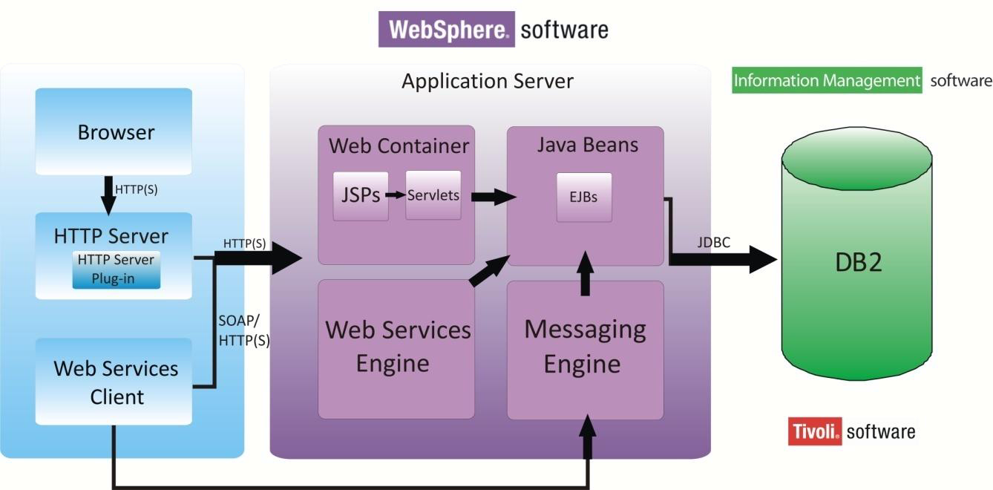

  - Hardware / Software Requirements :

Client Side

Software | Operating System | Processor | Disk Space | RAM
Browser (Internet Explorer, Mozilla Firefox, Opera) | ANY | Pentium II onwards, AMD Opteron onwards | 1 GB | 64 MB

Server Side

Software | Operating System | Processor | Disk Space | RAM
Websphere Application Server v 7.0 | Windows(Development End), ANY other can also be used | Pentium IV @500 MHz onwards, AMD Opteron onwards | 2 GB | 512 MB (minimum),  1 GB (recommended)
Database Server DB2 v 9.5 | Windows (Development End), ANY other can also be used | Pentium IV @ 500 MHz onwards, AMD Opteron onwards | 2 GB + data storage | 512 MB (minimum),  1 GB (recommended)
IBM Tivoli | Windows  (Development End), ANY other can also be used | Pentium !V @ 500 MHz onwards, AMD Opteron onwards | 10 GB+  Data storage | 1 GB (minimum)  2 GB  (recommended)

3.3 System Users:

- Buyers:-
.
- Post Feedback:-A buyer can post feedback on any book.
- View Feedback:-A buyer can also view the feedbacks posted by other users.
- Search for any Product:- A buyer can search any product on the bassis of Name of product ,Manufacture company .
- View Status of product:- A buyer can view the status of product.
- Request for any product:- A buyer can request for purchasing product that is not in stock.
- Registration:-A buyer would have to register for the purchasing to get ID for it.
- View Profile:-A buyer has also the rights to view the profiles of
other students and faculty.
- Manage Profile:-A buyer can manage his profile.

- Sellers:-
.
- Post Feedback:-A seller can post feedback on any book.
- View Feedback:-A seller can also view the feedbacks posted by other users.
- Search for any Product:- A seller can search any product on the basis of Name of product ,Manufacture company .
- View Status of product:- A seller can view the status of product.
- Request for any product:- A buyer can request for purchasing product that is not in stock.
- Registration:-A seller would have to register for the purchasing to get ID for it.
- View Profile:-A seller has also the rights to view the profiles of
other students and faculty.
- Manage Profile:-A seller can manage his profile.

Employee(Data Manager):-
- Manage Profile:- Data manager can manage his profile and update changes on it.
- View all details:-The data manager has rights to view any details on the website.
- Manage approved changes:-The data manager would have to modify the database according to the changes approved by the admin.
- Approve request for any book:- Data manger can approve requerst of any product.
- Manage books:- Data manager can manage products by knowing the status of any product.
- Send E-mail regarding delivery of book:- Data manager can send E-mail regarding the status of product.

- Admin:-
- Manage Profile:- The admin can modify and manage his profile.
- View all details:-The admin has the rights to view each and every detail on the website.
- Approve changes:-All the recommended changes before there implementation would have to be approved by the admin.
- Backup of data:-The admin is responsible to manage the backup of data.
- Approve Request of any book:- Admin can approve the request of any product.

- Advetiser- Anyone can advertise any product on the site.

- Guest:- they can view the advertisement of products.

3.4 Architecture Diagram :
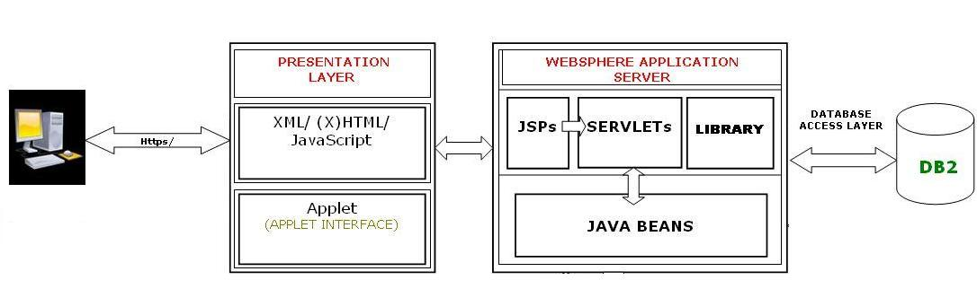

The above diagram basically depicts what is the architecture in the whole processing of our project that we have used. It clearly shows all the layers and what all layers are composed of. Each components are self explanatory and hence are not explained further.

The architecture of the whole project is based on the 4+1 view of the rational approach:-

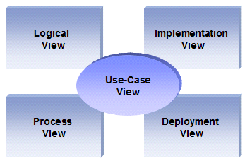

Logical view
Audience: Designers.
Area: Functional Requirements: describes the design's object model. Also describes the most important use-case realizations.
Related Artifacts: Design model

Process view
Audience: Integrators.
Area: Non-functional requirements: describes the design's concurrency and synchronization aspects.
Related Artifacts: (no specific artifact).

Implementation view
Audience: Programmers.
Area: Software components: describes the layers and subsystems of the application.
Related Artifacts: Implementation model, components.

Deployment view
Audience: Deployment managers.
Area: Topology: describes the mapping of the software onto the hardware and shows the system's distributed aspects.
Related Artifacts: Deployment model.

Use Case view
Audience: all the stakeholders of the system, including the end-users.
Area: describes the set of scenarios and/or use cases that represent some significant, central functionality of the system.
Related Artifacts : Use-Case Model, Use-Case documents.

Data view (optional)
Audience: Data specialists, Database administrators
Area: Persistence: describes the architecturally significant persistent elements in the data model
Related Artifacts: Data model.

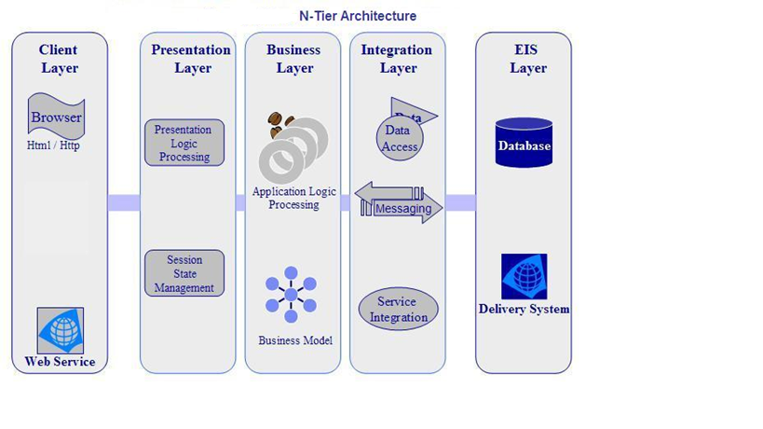
The layering model is based on a responsibility layering strategy that associates each layer with a particular responsibility.
This strategy has been chosen because it isolates various system responsibilities from one another, so that it improves both system development and maintenance.

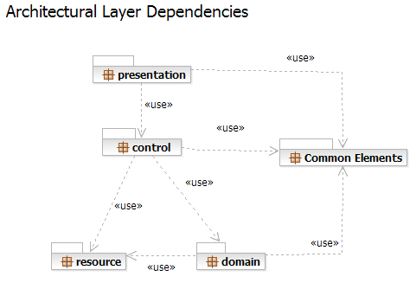

Each layer has specific responsibilities.

- The presentation layer deals with the presentation logic and the pages rendering

- The control layer manages the access to the domain layer

- The resource layer (integration layer) is responsible for the access to the enterprise information system (databases or other sources of information)

- The domain layer is related to the business logic and manages the accesses to the resource layer.

- The Common Elements layer gathers the common objects reused through all the layers

3.5 Deployment View Architecture of the Project:

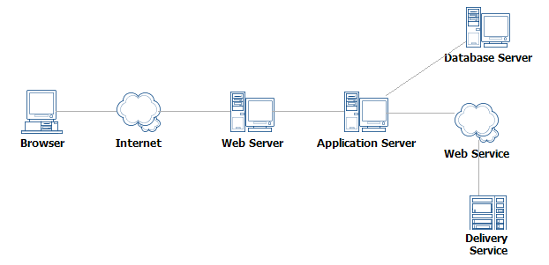

3.5 Assumptions and Dependencies :
No. | Requirement | Essential or Desirable | Description of the Requirement | Remarks
RS1 | The system should have a login | Essential | A login box should appear when the system is invoked. | The logins are assigned by the admin
RS2 | The system should have help screens | Essential | Help about the various features of the system should be provided in sufficient detail in a Q&A format. | In addition to the features of the system, a note on what are the supported facilities, who are the corresponding facility-heads etc should also be there.
RS3 | The system should ‘lock’ the login id if wrong password is entered 3 times in a row | Desirable | This feature will improve the robustness of the application | Since the application is going to be used only by the people inside the campus, this feature is not essential. However, if time is there, this will be implemented.
RS4
RS5

- By default, an Administrator account is created, who will further create a Data Manager account on the first login itself.
- Users are limited to Administrator, Data Manager, Faculty, Student and Guest.
- In case the timetable generation could not allocate a subject and room for a class, the Data Manager has to manually do it ; though he will be aided by the algorithm.

- Overall Description

4.1 Use Case Diagrams

Name of use case Registration

Description: Lets new users that is students and faculties to register themselves with the omicron website.
Preconditions:
- The user has connected to the omicron web interface.
- He has his id with himself.
Normal flow of events:
- The user logs in.
- The user fills his details.
- The account has been created.
Alternate flow of events: None.
Post Condition: None.

Name of use case: Manage Profile

Description: Lets registered users to manage their profiles to update changes and upload image.

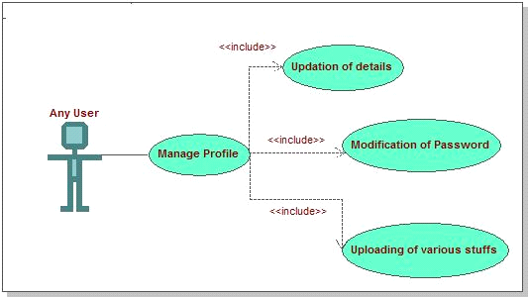
Preconditions:
- The user is logged in.
- The user provides valid information.
Normal flow of events:
- The user logs in.
- The user fills his details.
- Updates and saves the changes.
Alternate flow of events: None.
Post Condition: None.

Name of use case: Approval of changes
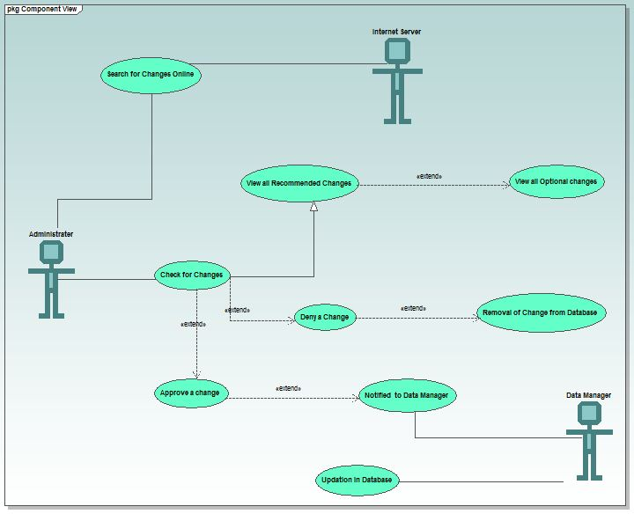
Description: Lets admin to approve the recommended changes by the employees and the data manager.
Preconditions:
- The admin is logged in.
- There have been some changes recommended for the admin to approve.
Normal flow of events:
- The admin logs in.
- He checks changes details.
- Approves the appropriate one’s.
Alternate flow of events: None.
Post Condition:
- The data manager logs in.
- He views the approved changes.
- He modifies them in the most appropriate way.

Name of use case: Buy /Sell Products

Description: This involves the buying or selling of products.
Preconditions:
- The data manager logs in.
- See request for books.
- He has to feed in the database all the details.
Normal flow of events:
- The data manager logs in.
- He fills in the required details.
- Order books
Alternate flow of events: None.
Post Condition:
- If some ambiguities are found then he has to manually generate the time table.

4.2 Activity Diagrams:-

Name of activity –User registration
Description –First step for buying and selling thing

Description-Initially user is made to fill all mandatory fields filled in registration form. Once the user clicks submit, the username is verified. If the username is already present, then the user is again taken back, so that he can change the username. If the username is not present then it checks for password and remaining mandatory fields. If any of the mandatory f ield is lef t empty or filled incorrect, then the user is informed to enter the correct values. Once all these verifications are succeeded, then the registration is done.

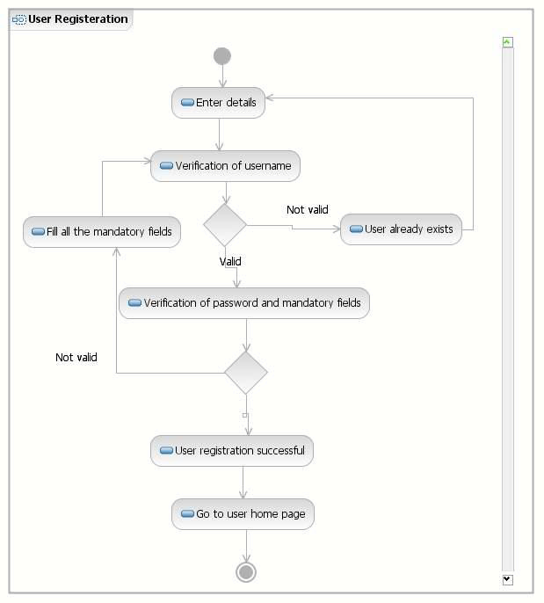
Name of activity –User Login Activity
User is made to enter username and password , then entered values are verified .
If it is a valid username and password then user is logged in otherwise user is asked to re-enter the correct values.
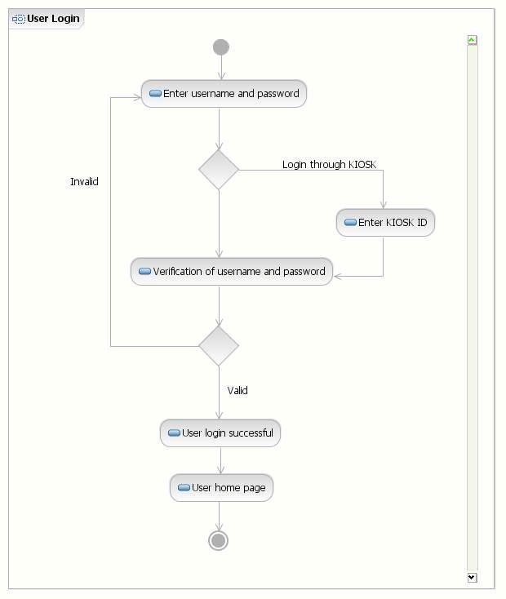

Name of activity: -Selection/Searching of Product
Description: The first step in the library.
Preconditions:
- The data manager has filled in all the details.
- The data manager is logged in.
Alternate flow of events: None.

Name of Activity- View profile.
Description: User can view own/candidate profile
. Preconditions:
➢ User must be login in account.

Normal flow of events:
➢ After login user can view own/candidate profile

Alternate flow of events: None.
Post Condition: None
.

Name of Activity: Run discussion forum.
Description: Candidate can run discussion forum.
Preconditions:
➢ User must be registered on site.

Normal flow of events:
➢ Candidate can run discussion forum.
➢ Communicate with user via forum.
Alternate flow of events: None.
Post Condition: None

Name of activity: -Request For A Change.
Description: This is a module in which every user has a privilege of suggesting the admin for some minor or major change in the campus. Any user can add problem or solution to an existing problem. It’s the burden of Admin then to either approve it, deny it or even leave it pending.
Preconditions:
- The User is logged in.

Alternate flow of events: None.

Post Condition:
- The Request is added in the database and left for admin to process it further.

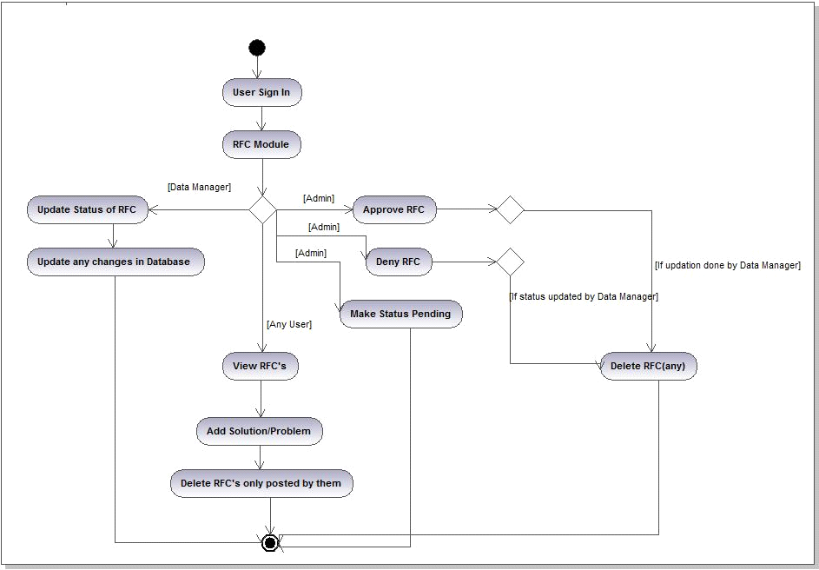

Name of activity: -Generation of Status of Products
Description: The admin can generate status of books by simply clicking on a button. The reports are generated through in excel and csv formats.
Preconditions:
- The Admin is logged in.
- Status of books is updated in Database
- MS-EXCEL is installed.

Alternate flow of events: None.

Post Condition:
- The Status Report is generated.

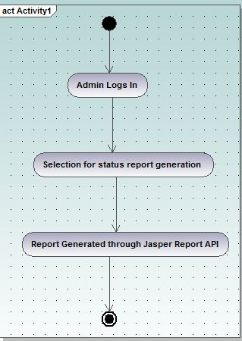

Name of Activity-Lodging Complaint activity

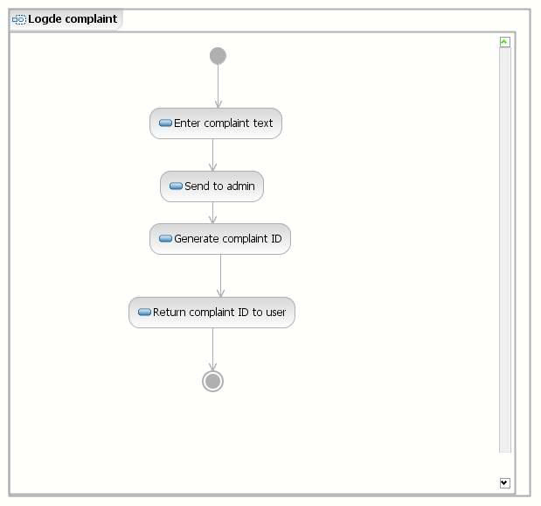

Name of Activity Participate in Discussion Forum
Description - The system displays all the posts to the users. The user can select a thread from the recent posts and can reply for that post or he/she can create the new post. The user can directly create a new thre adand in that he/she can create a new post. The user can also search for a particular topic and can select a thread from the results and can create a new post.

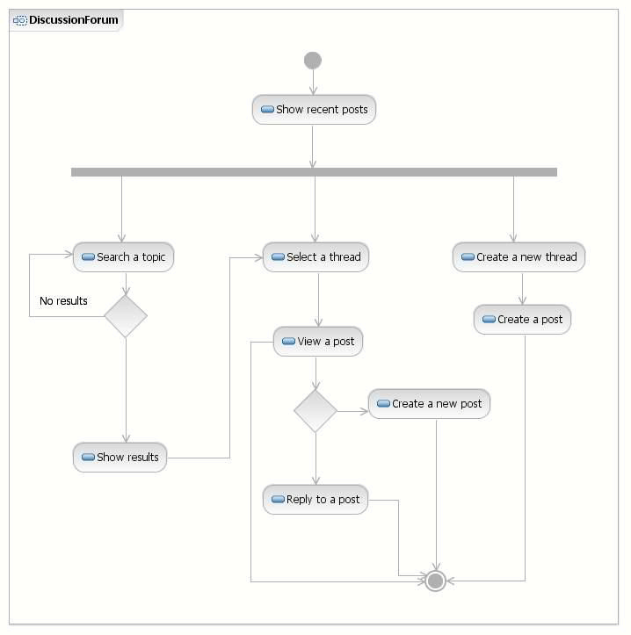

Name of activity: - WEB 2.0.

Description: WEB 2.0 support is used and the users are given facilities like forum, chatting and RSS feeds on notices.
Preconditions:
- The User is logged in.
- Chat Server is started by the Data Manager.

Alternate flow of events: None.
4.3 Sequence Diagrams

User Login Sequence Diagram

Login:
In order to access other specific functionalities a user must login to the system. All users can login to the system using their user name and password. Name of use case: login Description: client enters user name and password and the system authenticates the user. Preconditions: The user account is existing in the database and has not yet logged in. Normal flow of events:
✓ The client enters user name and password.
✓ Javascript validates the provided information using regular expression.
✓ The Jsp page passes the request to Servlet.
✓ The Servlet checks against database and returns true.
✓ A bean instance is created and property is set by javascript.
✓ User is asked for the option of continuing with previous session by java script.
✓ Based on user input the session detail is got from Servlet and DOM is updated.

Alternative flow of events:
✓ The client enters user name and password.
✓ Javascript validates the provided information using regular expression.
✓ The Jsp page passes the request to Servlet.
✓ The Servlet checks against database and returns true.
✓ The Jsp page is updated with corresponding error message.

Change password: Sequence Diagram
A user of the system would be provided a default password at the beginning. To maintain privacy he/she can change his/her password. Name of use case: Change Password Description: client enters the new password in order to replace his existing password. Preconditions: The user account is exists in the database and user has logged in. Normal flow of events:
✓ The client clicks the button.
✓ Jsp page asynchronously requests the servlet.
✓ Servlet forwards the request to EJB.
✓ The Servlet checks against database and returns true.
✓ EJB makes changes to the database.
✓ EJB reports the change to servlet.
✓ Servlet similarly reports back to the JSP which updates the DOM.

Add User
Super Admin may add a new user of the system. Name of use case: Add new user Description: Super user may add new user to the system. Preconditions: The user account exists in the database; user has logged in and has perquisite privileges. Normal flow of events:
✓ The client provides the user details.
✓ The client clicks the button.
✓ Jsp page asynchronously requests the servlet.
✓ Servlet forwards the request to EJB.
✓ EJB insert details into database.
✓ EJB generate the report and forward it to servlet.
✓ Servlet similarly forwards the report back to the JSP
✓ JSP updates the DOM to display the report

Lodge Complaint Sequence Diagram
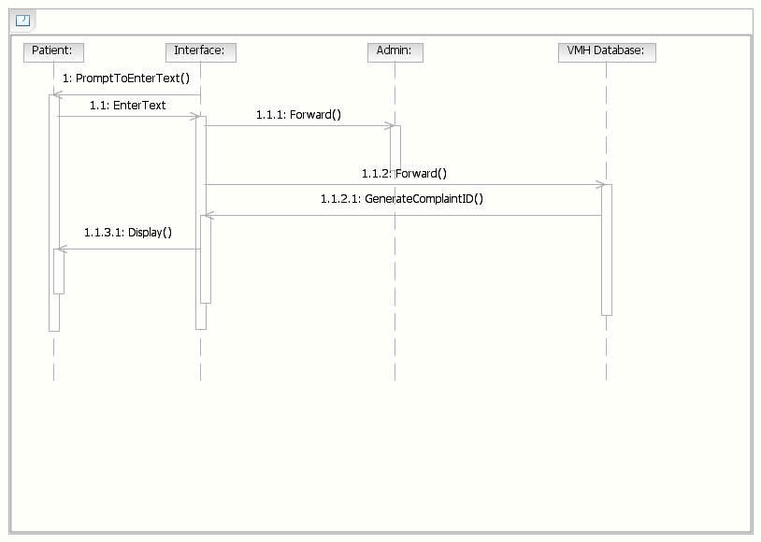

View help:
A 24x7 help feature would be provided. The help is available both online and offline. The user may access help feature that is convenient to him.

• Customize profile: Sequence Diagram

To give user a better look and feel, the system boasts several kinds of skins and theme. The user can customize his profile by selecting one from the available. Name of use case: Customize profile Description: client customizes his/her profile by choosing from predefined skins. Preconditions: The user account is exists in the database and user has logged in. Normal flow of events:
✓ The client chooses the skin.
✓ The client clicks the button.
✓ Jsp page asynchronously requests the servlet.
✓ Servlet forwards the request to EJB.
✓ EJB makes changes to the database.
✓ EJB reports the change to servlet.
✓ Servlet similarly reports back to the JSP
✓ JSP updates the DOM

Authentication of Privilaged User Sequence Diagram

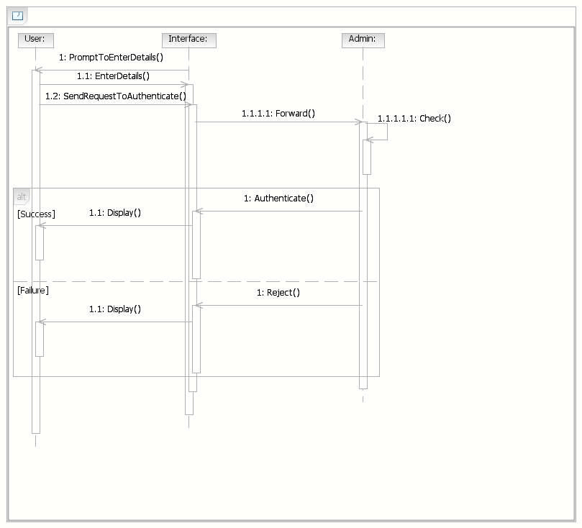

Generate report
Name of use case: Generate report Description: government official user generates a cumulative report. Preconditions: The user account exists in the database; user has logged in and has perquisite privileges. Normal flow of events:
✓ The client provides the lists to generate report.
✓ The client clicks the button.
✓ Jsp page asynchronously requests the servlet.
✓ Servlet forwards the request to EJB.
✓ EJB queries the database.
✓ EJB generate the report and forward it to servlet.
✓ Servlet similarly forwards the report back to the JSP
✓ JSP updates the DOM to display the report.

Change Database Location
Super Admin may change the IP address and port no of database location easily. Name of use case: Change database location Description: Super user may change IP address and port of database location. Preconditions: The user account exists in the database; user has logged in and has perquisite privileges. Normal flow of events:
✓ The client provides IP address and port number.
✓ The client clicks the button.
✓ Jsp page asynchronously requests the servlet.
✓ Servlet forwards the request to EJB.
✓ EJB makes changes to database.
✓ EJB generate the report and forward it to servlet.
✓ Servlet similarly forwards the report back to the JSP
✓ JSP updates the DOM to display the report

- Key Feature

5.1 Supplementary Requirements:

✓ 24 x 7 Availability - If the base is now the entire world, staying open 24 hours a day becomes critical. Because system can be an automated Process, so it can stay open for 24 hours a day. So UPS support must be on server site for at least 8 hours in case of power failure. System will remain inaccessible to users at 2:00 to 4:00 am for backup and maintenance purpose.

✓ Dynamic Website - Many early Web implementations consisted of static HTML pages. This becomes very difficult to manage if the number of pages gets too large. An effective system should be largely dynamic taking advantage of technology that automates this process rather than relying on manual processes. Application should serve dynamic user based customized web pages to its clients from server.

✓ Integration with existing enterprise systems – Any existing Web site that relies on the manual duplication of data from another system is one that can be improved. Most of the business data in the world today exists in enterprise servers that can be connected to the Web servers to make this process far more effective.

✓ Provide good performance and the ability to scale the server – The Web application Server should provide good performance and the ability to manage performance with techniques, such as support for caching, clustering, and load balancing.

✓ Providing session management capability - Web application developers should not spend valuable time worrying about how to maintain sessions within the application. The Web Application Server should provide these services.

- Server Performance – The modern server is needed with advance features like load balancing, clustering, database connection pooling and caching.

- Session Management – The server should be inherently capable of handling sessions, so that the developer hs to be least worried about such trivial details.

5.1 Use of XML:-

(a) Really Simple Syndication (RSS) :-
(b) Extensible Stylesheet Transformation (XSLT)
(c) Use of XML datatype in DB2 database :-
(d) Use of Ajax
(e) Xquery is used as a query language
DB2 with PUREXML

(f) Service Oriented Architecture (SOA) is also used to expose useful modules as WebServices :-
DB2 with PUREXML

HTML Form
XForm

Webservice application which will have registration form and a search engine which will search for particular information regarding different products.

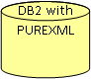

Advantages of using Pure XML

- Because of the use of XForms which generate XML data as input, its easy to consume (gather) all user information in a single XML document and store it as a single entity without breaking it up into pieces as done is case of relational database.
- Since the data will be stored in a single XML document, its easy to fetch it using a simple XQuery without any complex joins
- Since the data is stored as XML, it is very easy to construct SOAP messages from this XML content as no relational to XML transformation is required.
- Use of XSLT to report data in multiple format is now possible because of the XML data model.
- XML Indexes can be used to further increase the XQUERY performance.
- Xml functions can be used to query the data efficiently as the data given by a person will not be in a proper format , for example a person living in delhi can give , New Delhi or Delhi. And also if someone wanted to sell a mobile phone he can write only cell phone or phone etc

4.3 Plus Points in Design:-

We have opted a modular approach in our coding though the use of STRUTS(a famous J2EE framework). The use of STRUTS has divided our project into separate modules which are complete in themselves and are independent of others that is providing high cohesion and low coupling to our project. The use of a good directory structure and proper coding conventions has added to the design features of our project.

Implementation of SOA( Service Oriented Architecture) in modules like Time Table Generation has even made our project more useful as these services can be easily integrated by any user outside the project and hence adds to the usability of the project running at one place but providing service at multiple centres.

Use of RSS(Really Simple Syndication) Feeds on the notices provides automatic notification to the subscribed users about any new notice that has been updated by the admin.
Use of SSL(Secure Socket Layer) for secure login of the user and thereby ensuring the security of the project.

Using many techniques for faster browsing of the Web Pages like switching between HTTPS and HTTP, use of compression through JAVA and use of XML as a data type in the database.

The project can be quiet easily maintained as it is having a central data source for database management. The design is architecture neutral as there is use of JAVA. There is application based management of resources as switching between HTTPS and HTTP is completely controlled by the application itself and not by the container.

The cost of the project is also controlled by the use of open source soft wares which reduces installation and maintenance costs. User ease is also taken into account by providing very easy GUI for the user to interact. The use of AJAX at many places has made the project even more friendly and responsive to user.

Number | Milestone Name | Milestone Description | Timeline  Week no.  from the start  of the project | Remarks
1 | Requirements Specification | Complete specification of the system (with appropriate assumptions) including the database design (for storing the books/journals details). A document detailing the same should be written and a presentation on that be made. | 1-2 | Attempt should be made to add some more relevant functionalities other than those that are listed in this document.
2 | Technology familiarization | Understanding of the technology needed to implement the project. | 3-4 | The presentation should be from the point of view of being able to apply it to the project, rather than from a theoretical perspective.
3 | High-level and Detailed Design | Listing down all possible scenarios (like searching for product/ reserving a product, submitting a purchase application for new product etc) and then coming up with flow-charts or pseudocode to handle the scenario. | 5-7 | The scenarios should map to the requirement specification (ie, for each requirement that is specified, a corresponding scenario should be there).
4 | Implementation of the front-end of the system | Implementation of the main screen giving the login, screen that follows the login giving various options, screens for buyers /sellers and company for the various functions etc. | 7-9 | During this milestone period, it would be a good idea for the team (or one person from the team) to start working on a test-plan for the entire system. This test-plan can be updated as and when new scenarios come to mind.
5 | Integrating the front-end with the database | The front-end developed in the earlier milestone will now be able to update the books/journal database. Other features like mail notification etc should be functional at this stage. In short, the system should be ready for integration testing. | 10-12
6 | Integration Testing | The system should be thoroughly tested by running all the testcases written for the system (from milestone 5). | 13-14 | Another 2 weeks should be there to handle any issues found during testing of the system. After that, the final demo can be arranged.
7 | Final Review | Issues found during the previous milestone are fixed and the system is ready for the final review. | 15-16 | During the final review of the project, it should be checked that all the requirements specified during milestone number 1 are fulfilled (or appropriate reasons given for not fulfilling the same)

Special Thanks












We also convey a special thanks to all these software’s and websites, they have been helping a lot in doing the project.

